Training Curve analysis

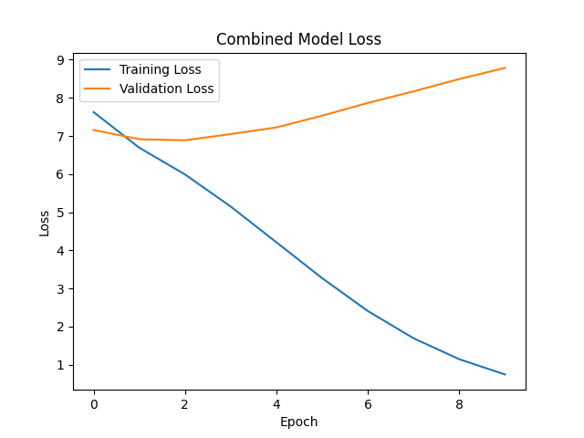

Training Loss (Blue Line)

The training loss consistently decreases over the epochs, dropping from 7.6275 in Epoch 1 to 0.7460 in Epoch 10. This steady decline indicates that the model is effectively learning from the training data, demonstrating significant improvement in performance. The loss reduction is particularly rapid in the initial epochs, which is typical as the model begins to converge on the underlying patterns of the data. This trend highlights the model's ability to adapt and optimize its parameters effectively.

Validation Loss (Orange Line)

The validation loss shows a similar downward trend but decreases at a slower rate compared to the training loss. Starting at 7.1583 in Epoch 1, it drops to 6.8872 in Epoch 3. However, from Epoch 4 onwards, the validation loss begins to increase, reaching 8.4934 by Epoch 9. This suggests that while the model initially generalizes well to the validation dataset, it starts to overfit as the training progresses. The increase in validation loss after a certain point indicates that the model is becoming less effective at generalizing from the training data to unseen data.

Comparison of Losses

The gap between the training and validation losses remains relatively small throughout the epochs, which is a positive indicator of the model's performance. It suggests that the model is not significantly overfitting, as both losses are closely aligned. However, the divergence in validation loss after Epoch 4 serves as a warning sign. If the validation loss continues to rise while the training loss decreases, it could indicate that the model is fitting the training data too closely, compromising its ability to generalize effectively.